

**SETUP DOCUMENT**

**From:** **Group 9**

* **Le Viet An**
* **NguyenBao Quoc**
* **Elahe Seyedkabirian**
* **Amin Jahromi**

# Contents

Contents 2

1.Introduction 3

2.Agreement with client 3

3.Processes 4

4.Functional requirenments (MoSCoW) 5

4.1 Website functional requirenments 5

4.2 Application functional requirenments 6

5.GUI 7

6.ERD 11

7.Website wireframe 12

8.Reflections 23

8.1 Reflections ( NguyenBao Quoc) 23

8.2 Reflections ( An Le) 24

8.3 Reflections (Elahe Kabirian ) 26

8.4 Reflections (Amin Jahromi ) 27

# 1.Introduction

The setup document presents an over view on software services which our team (Eventive) is going to provide to hold an event.

# 2.Agreement with client

Our team will invoice Client “Mr. Vladimir Kabzir“for Services will be performed within 20 weeks of performance.  This agreement makes us responsible to provide a software solution which has functionalities (mentioned in this document) before, during and after the event.

# 3.Processes

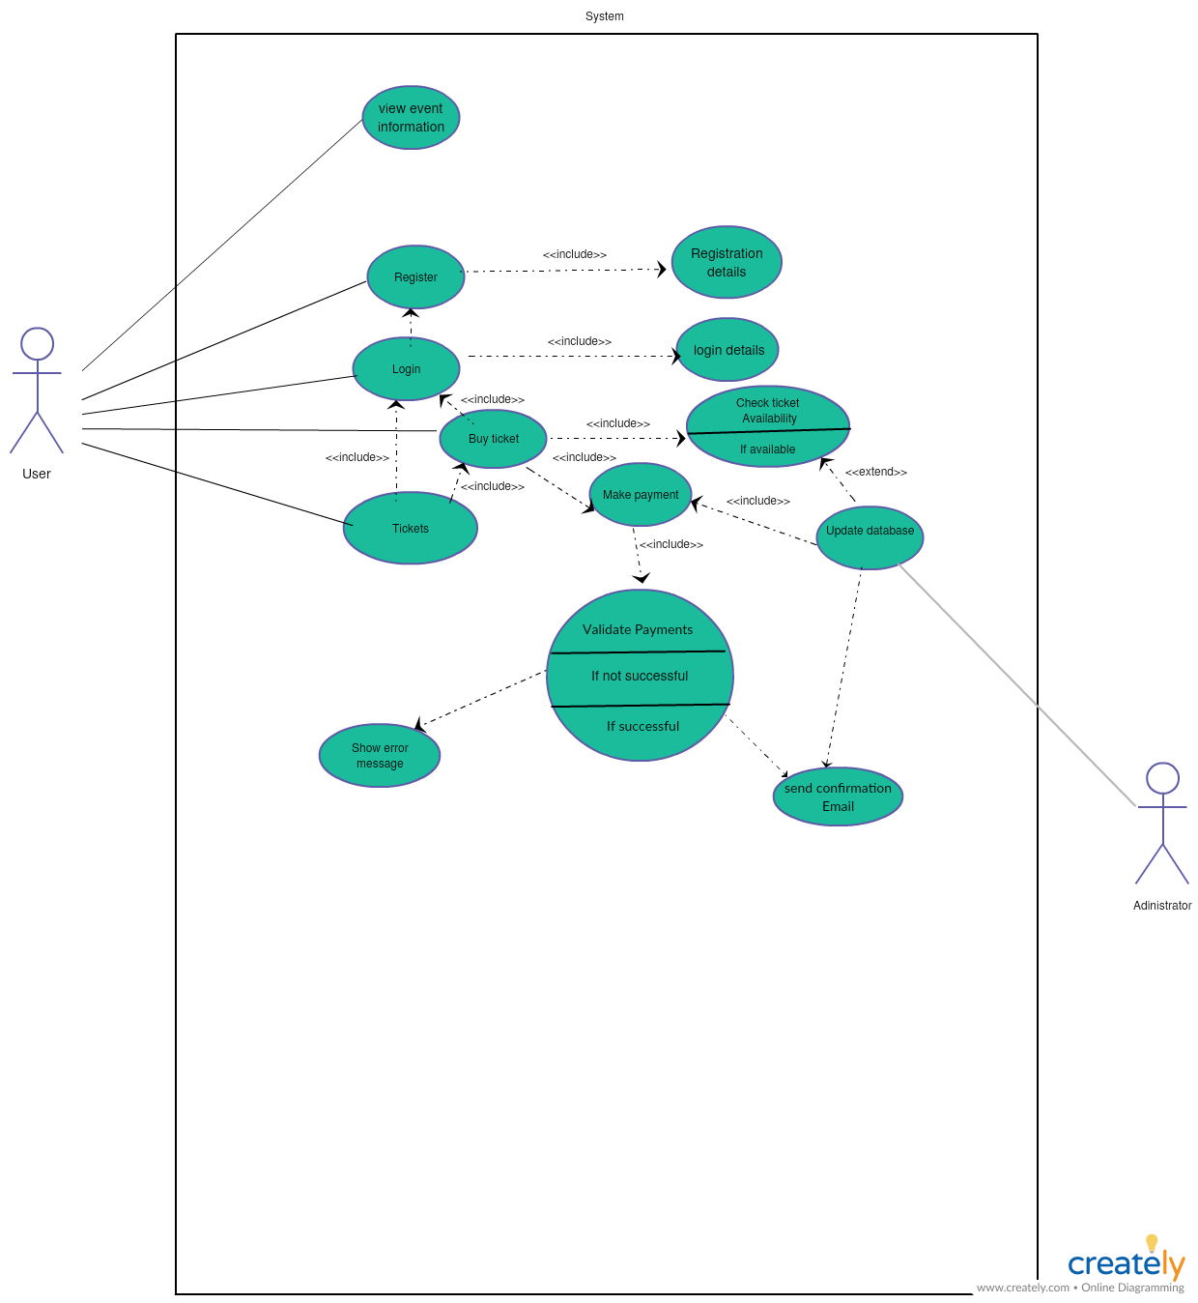

# 4.Functional requirenments (MoSCoW)

# 4.1 Website functional requirenments

|  |  |
| --- | --- |
| **Website MoSCoW Prioritisation** | |
| **Must have** | * Must be connected to database and application * Must be able to be updated by database * Must allow people to buy entrance tickets and reserve camping spots and tents * Must send a confirmation Email to people after buying ticket * Must be possible for visitors to deposit money to their event-account through the website |
| **Should have** | * Should be user-friendly * Should be easy to find needed links without a lot of searching and clicking to find the information * Should be mobile friendly |
| **Could have:** | * Could be designed based on musical instruments * Could be some review message or comment space in website for visitors to share their experience |
| **Won’t have:** | * Visitors won’t be able to reserve materials (USB, camera….) through the website * Visitors won’t be able to buy food and drinks through the website |

# 4.2 Application functional requirenments

|  |  |
| --- | --- |
| **Application MoSCoW Prioritisation** | |
| **Must have** | * Check the ticket if the user is allowed to enter the event * Selling tickets at the entrance of event if visitors have not purchased tickets yet * Store the details of transactions when visitors use their cards to pay for foods or loaned device * Visitors history(transaction, check-in or check-out, deposit) * Check if visitors have paid for camping spot or not. * check the unique identity number, generate a receipt and lower the balance of the event-account of the visitor by the amount of the purchase * Check the balance of visitor’s event-account when they leave. |
| **Should have** | * Total visitors (to visit the event) * Total balance of all visitors together & total spent money * Total amount of a certain product sold |
| **Could have:** | * Menu bar |
| **Won’t have:** | * Another application |

# 5.GUI

The app is created only for client and employees. For different roles, the application will automatically show different functions. Only the client(admin) can access all the functions to track the process of the event (income, number of visitors). For employees, for example, at the food store will only have the right to enter, export and update food information in the store.

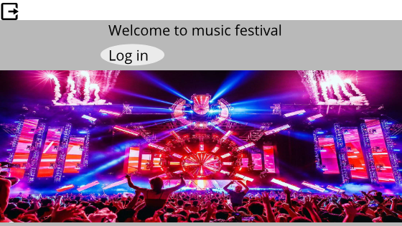

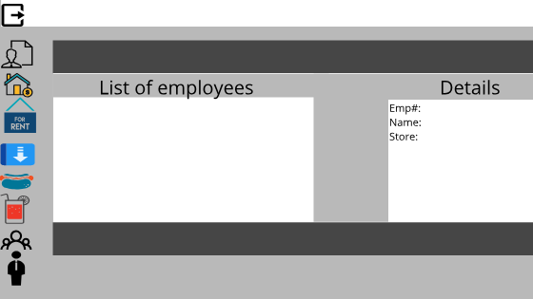

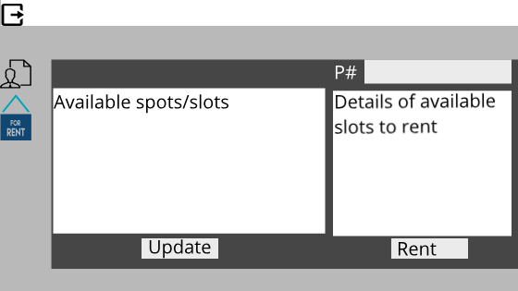

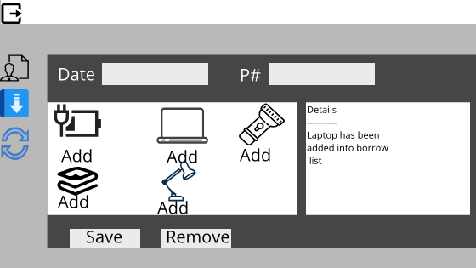

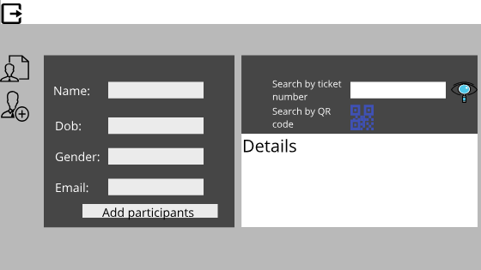

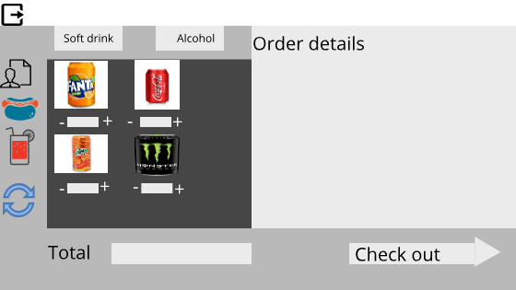

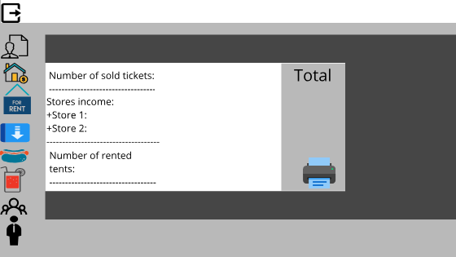

# 6.ERD

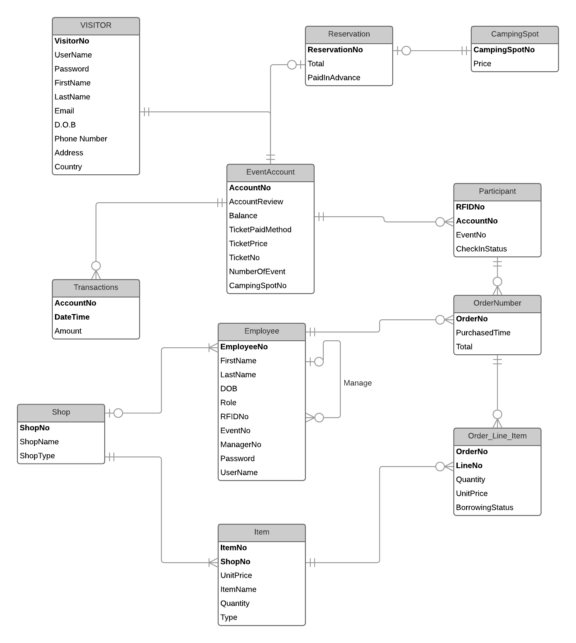

The ERD is designed to support the website as well as the application. The ERD can be transformed to the database which help the users keep track of certain things throughout the event. First and foremost, users can know status of the whole event, for instance the staffs can know the total amount of participants in the event, how many people have checked in/ out, which reservations are made by the participants (tents, loan materials). Secondly , the ERD is designed to keep track of transactions made by the participants during the event and gives information about the participants balance in their event account. Apart from that, the ERD help the application, which is used by staff members of the event, keep track of the amount of drinks have been sold, which loan material is being used, and help the application print the receipt for the buyers. Finally, give an overview of the whole event, for example, the total money they made, which loan materials are not given back yet, what is the profit of certain shop,…

# 7.Website wireframe

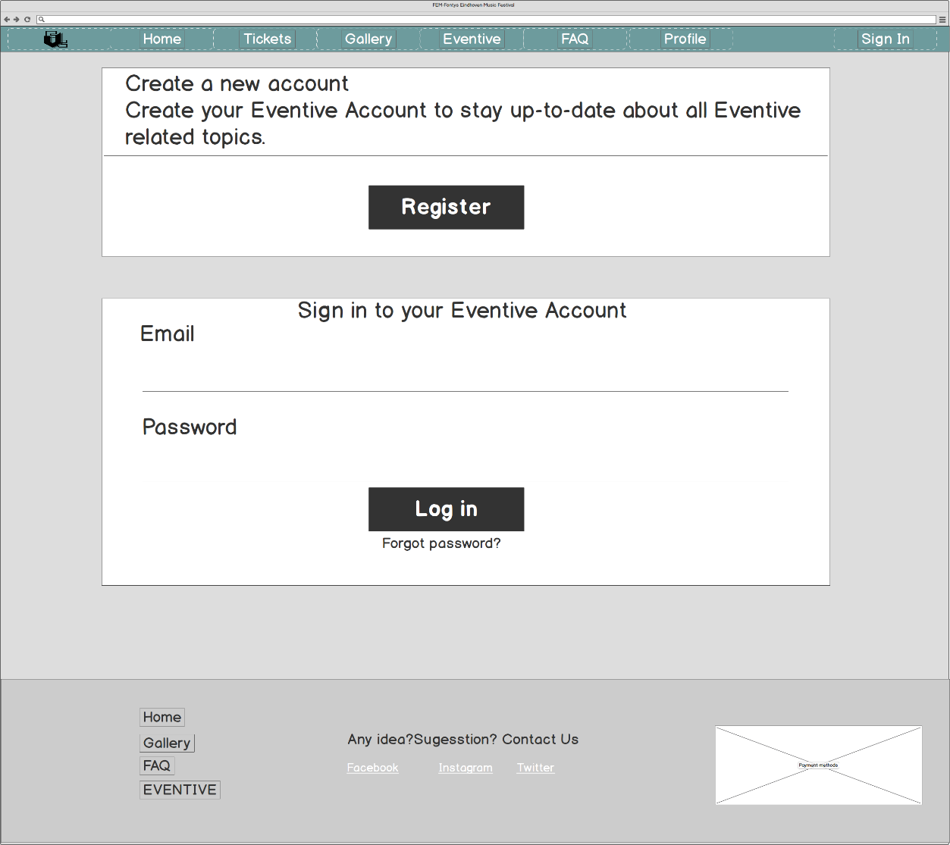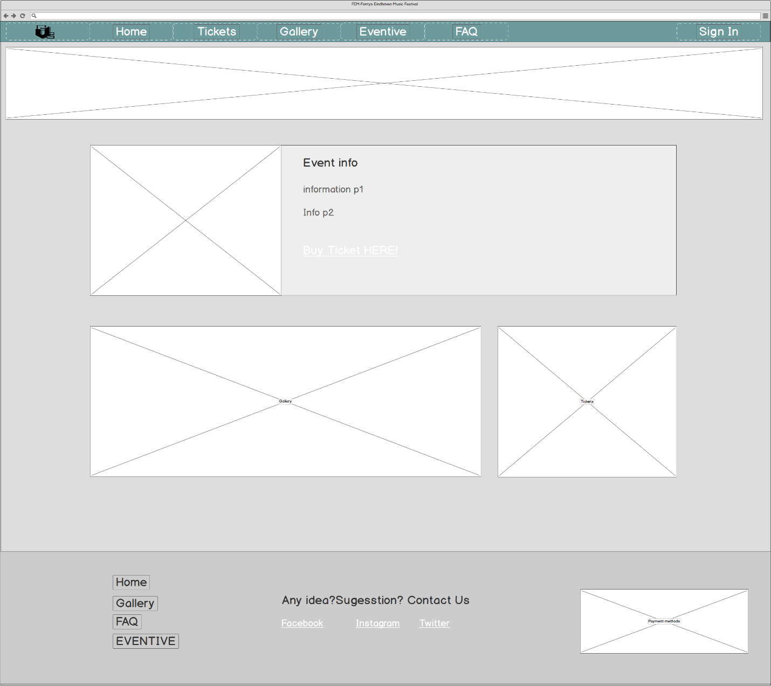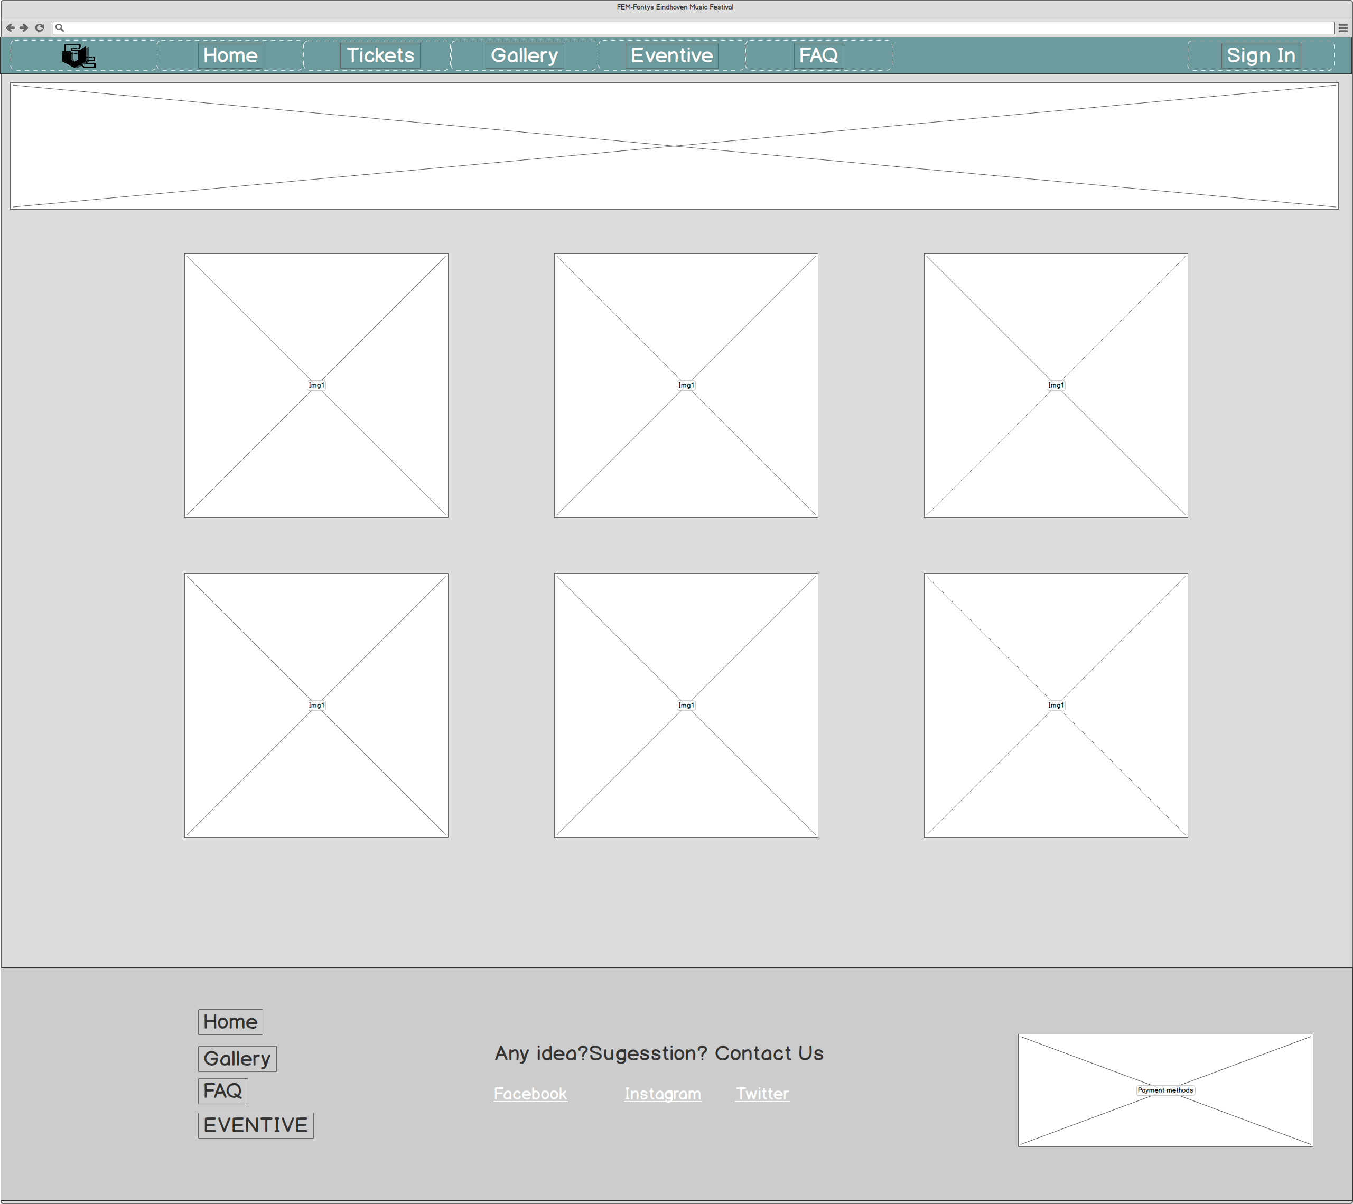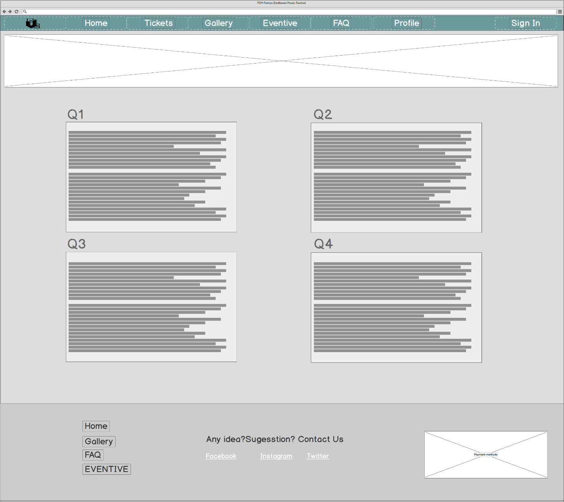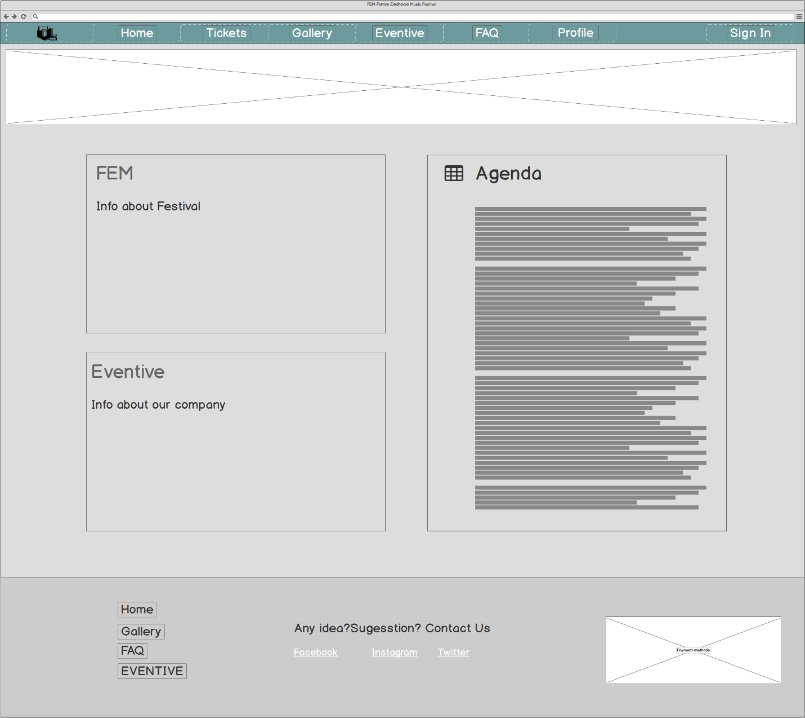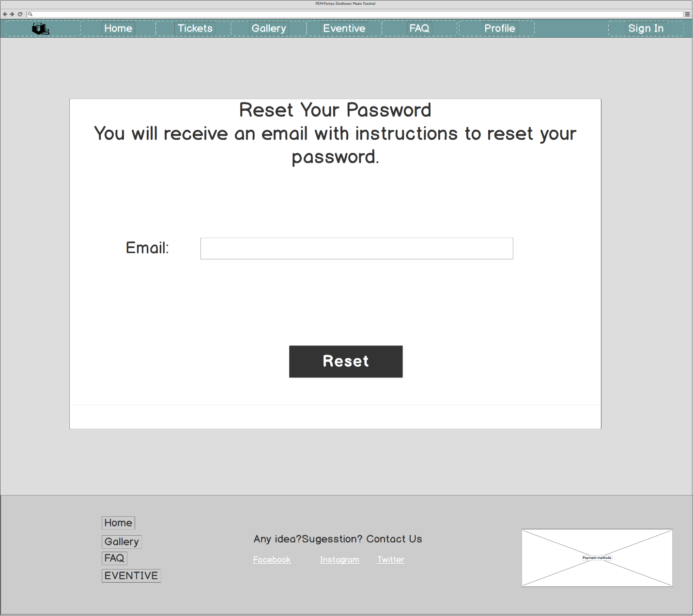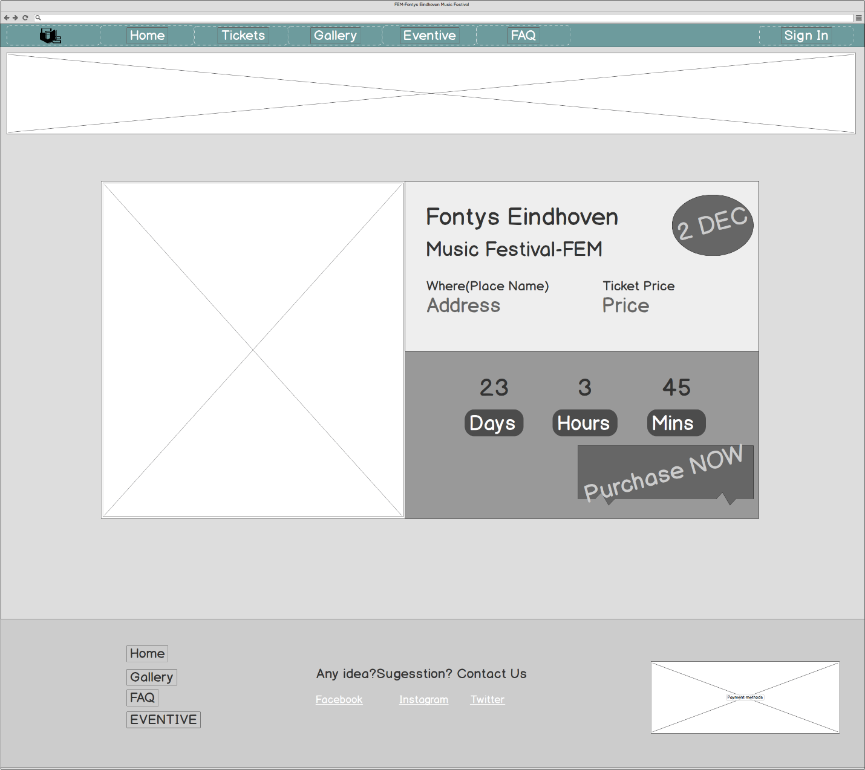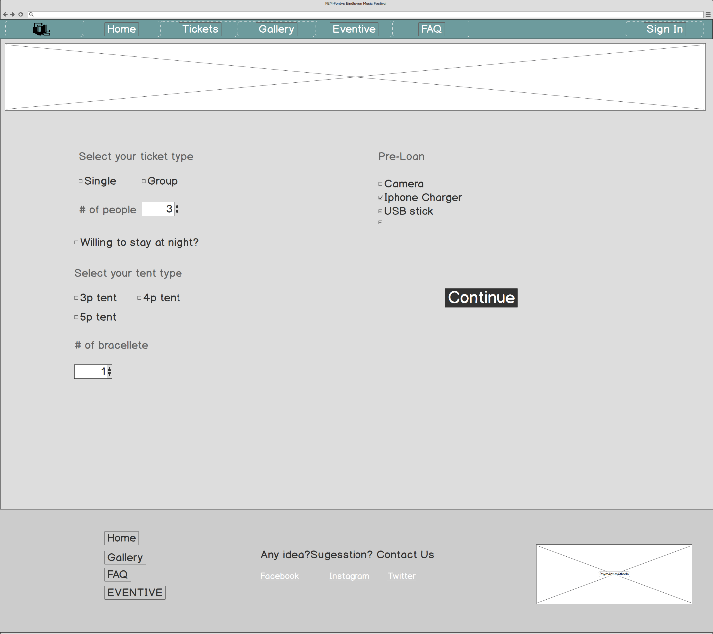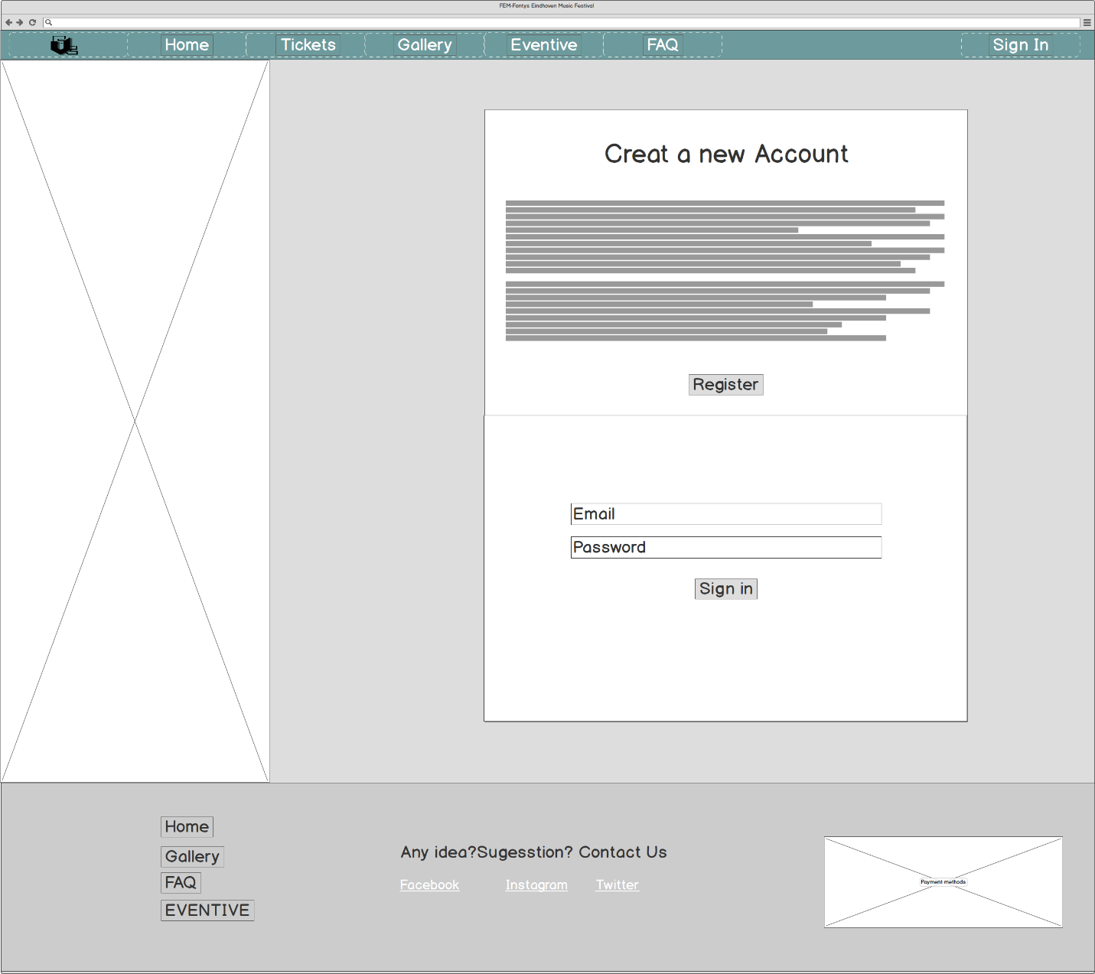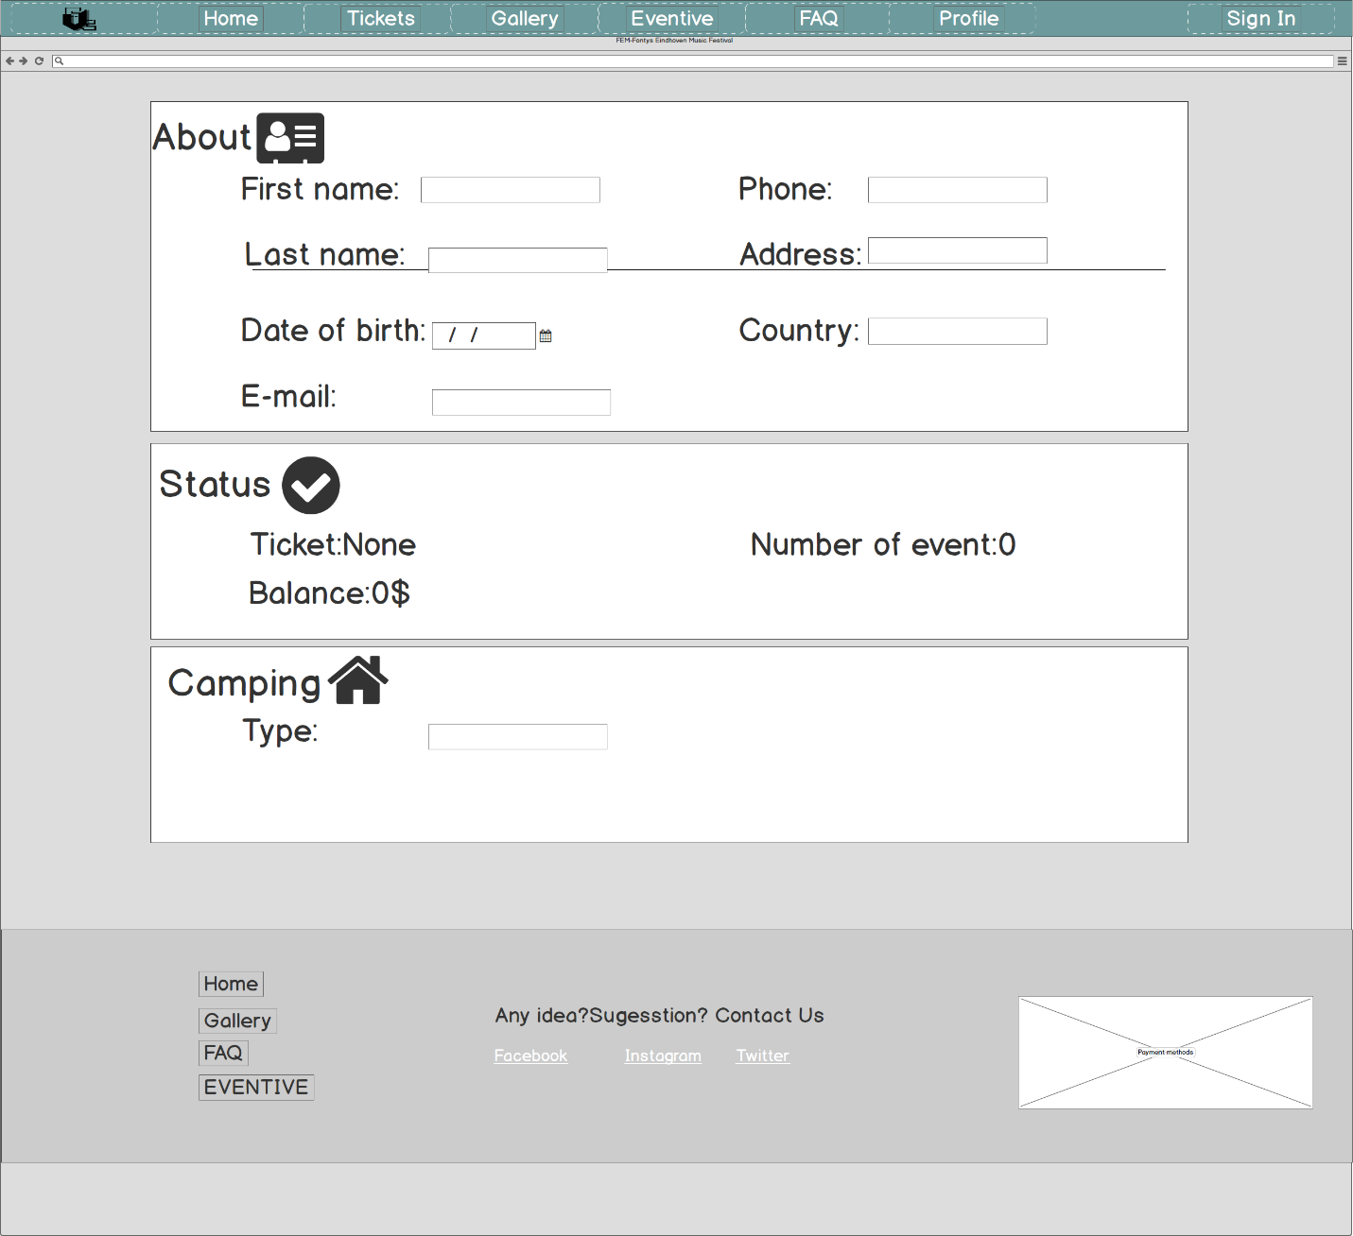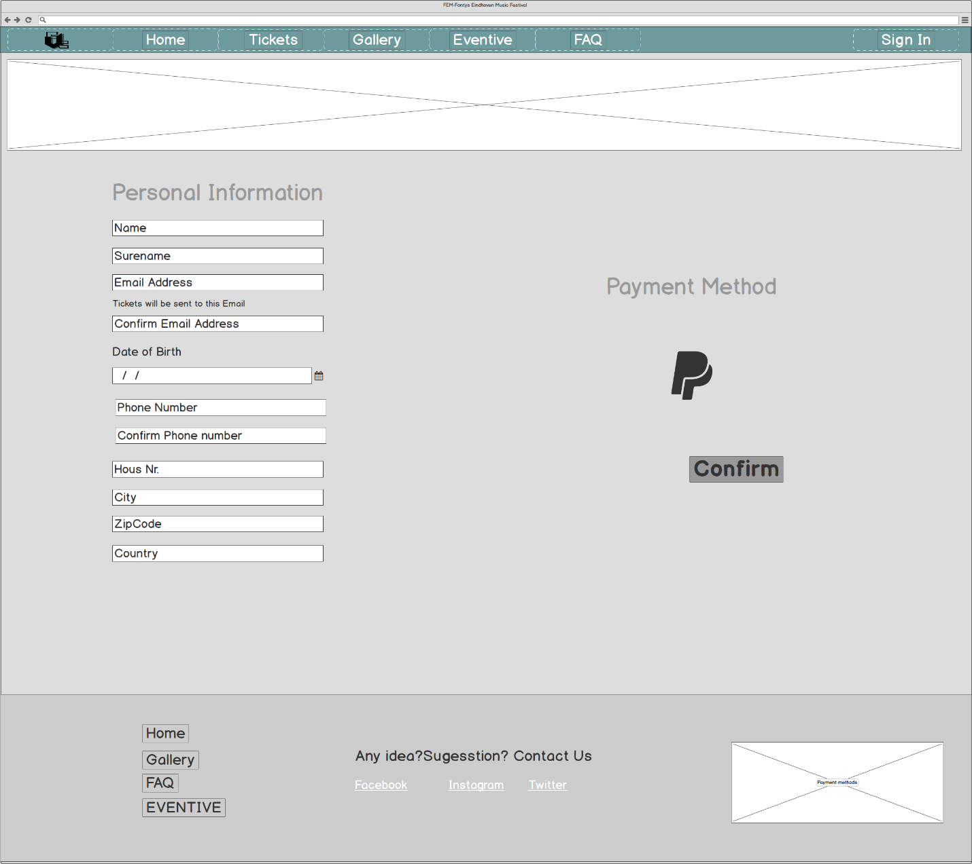

# 8.Reflections

# 8.1 Reflections ( NguyenBao Quoc)

|  |  |  |  |  |
| --- | --- | --- | --- | --- |
| **Item** | ***Quoc*** | ***Elahe*** | ***Amin*** | ***Le An*** |
| 1. Is always on time | ++ | ++ | ++ | ++ |
| 2. Follows up appointments | ++ | ++ | ++ | ++ |
| 3. Takes care of documents | + | ++ | + | + |
| 4. Quality of the work | ++ | ++ | + | ++ |
| 5. Contribution to the discussions | ++ | ++ | ++ | ++ |
| 6. Contribution of original ideas | ++ | ++ | ++ | ++ |
| 7. Is working hard | ++ | ++ | ++ | ++ |
| 8. [*your item*] |  |  |  |  |
| 9. General appreciation  (mark 1…10) | 9.5 | 10 | 9 | 10 |

# 8.2 Reflections ( An Le)

|  |  |  |  |  |
| --- | --- | --- | --- | --- |
| **Item** | ***An Le*** | ***Elahe*** | ***Amin*** | ***Quoc*** |
| 1. Is always on time | + | ++ | ++ | ++ |
| 2. Follows up appointments | ++ | + | + | ++ |
| 3. Takes care of documents | + | ++ | + | + |
| 4. Quality of the work | + | + | + | ++ |
| 5. Contribution to the discussions | + | + | + | ++ |
| 6. Contribution of original ideas | ++ | ++ | ++ | ++ |
| 7. Is working hard | + | + | + | + |
| 8. [*your item*] |  |  |  |  |
| 9. General appreciation  (mark 1…10) | 9 | 9 | 9 | 10 |

# 8.3 Reflections (Elahe Kabirian )

|  |  |  |  |  |
| --- | --- | --- | --- | --- |
| **Item** | ***ELAHE*** | ***An Le*** | ***Amin*** | ***Quoc*** |
| 1. Is always on time | + | + | ++ | ++ |
| 2. Follows up appointments | ++ | ++ | ++ | ++ |
| 3. Takes care of documents | ++ | + | ++ | + |
| 4. Quality of the work | + | ++ | ++ | ++ |
| 5. Contribution to the discussions | ++ | ++ | ++ | ++ |
| 6. Contribution of original ideas | ++ | ++ | ++ | ++ |
| 7. Is working hard | + | + | ++ | ++ |
| 8. [*your item*] |  |  |  |  |
| 9. General appreciation  (mark 1…10) | 9.5 | 9.5 | 10 | 10 |

# 8.4 Reflections (Amin Jahromi )

|  |  |  |  |  |
| --- | --- | --- | --- | --- |
| **Item** | ***Amin*** | ***An Le*** | ***Elahe*** | ***Quoc*** |
| 1. Is always on time | ++ | ++ | ++ | ++ |
| 2. Follows up appointments | ++ | ++ | ++ | ++ |
| 3. Takes care of documents | ++ | ++ | ++ | + |
| 4. Quality of the work | + | ++ | ++ | ++ |
| 5. Contribution to the discussions | ++ | ++ | ++ | ++ |
| 6. Contribution of original ideas | ++ | ++ | ++ | ++ |
| 7. Is working hard | ++ | ++ | ++ | ++ |
| 8. [*your item*] |  |  |  |  |
| 9. General appreciation  (mark 1…10) | 9 | 10 | 10 | 10 |